Pre-LAB REPORT

for
Lab Assignment #3:
Meeting Room Controller

Table of contents:

1. Introduction………………………………………………………………….………..1

2. Functional Behavioral Requirements……………….………………………….…..1

4. Simulation Testing Plan………….………………………………….………..……..2

5. Prototype Testing Plan…………….………….…………..…………….....………..2

6. Result of Testing………...………………………………………………….………..2

7. Answer To Questions…...………………………………………………….………..2

8. Conclusion………….……………………………………………………….………..3
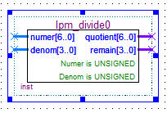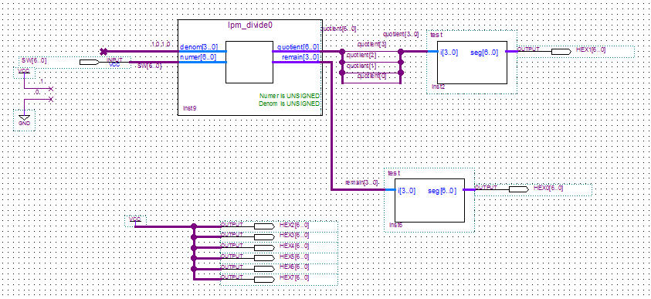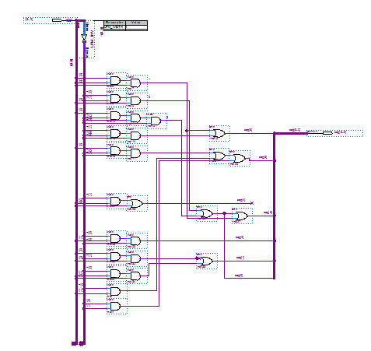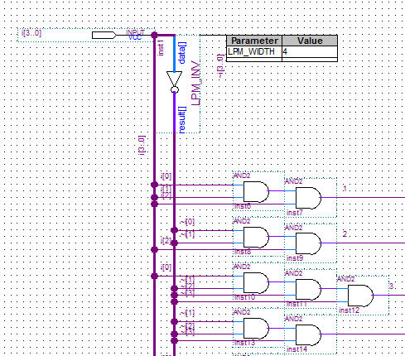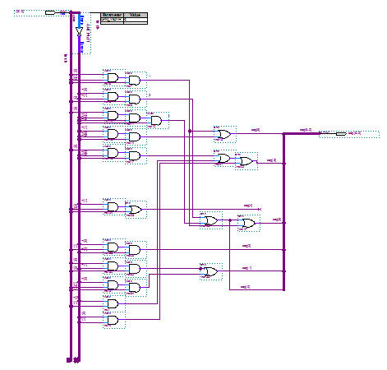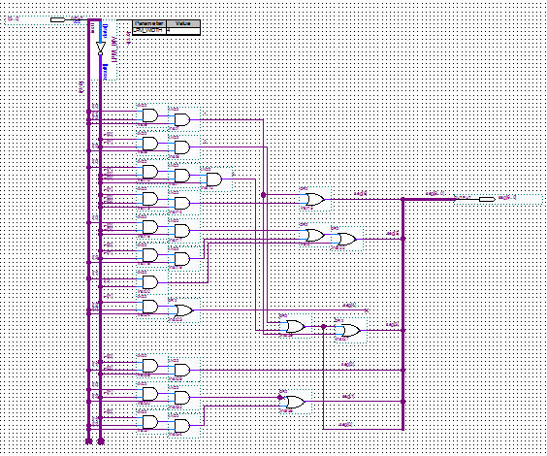
1. Introduction

“ In this lab assignment, students will utilize basic knowledge of Boolean algebra, binary numbers, radix number conversion, and logic minimization to design and optimize a modular combinational logic circuit which will convert input numbers in the range 0-99 from raw binary form into pairs of decimal digits that are visible to the user. This circuit can then be used as a component in later assignments. This lab is done as a structured design process, though with somewhat less documentation required than in lab #1. Students design and test their circuits at home in simulation for the pre-lab, and then test their designs in lab on the actual development boards.”

-- quoted from Lab Assignment #3 document.

2. Functional Behavioral Requirements

System-level functional requirement1: Take as input a binary representation of a number from 0 to 99.

System-level functional requirement2: Display the corresponding decimal digits in a form that is visible to and readily understandable by any human viewer

4. Simulation testing plan
With the use of Quartus and the “Simulator Tool” we can make sure the outputs are what we expect. The steps include creating input waveforms for the input nodes, starting the simulation, viewing the report, comparing waveforms with output waveforms, and lastly making sure the delay is non due to functional simulation.

5. Prototype testing plan

During the lab, to systematically test all of the design functional requirements I will take the following steps:
Step1: Make sure the program is compiled correctly.
Step2: Test each switch (All 7) for every binary number 1-99

6. Answers to Questions

Question #1.
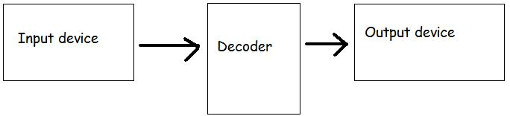

Question #2.
1100011 is 99 in binary, and it has 7 bits. So this is the minimum number of bits that will be

Question #3.
Given the size of the input signal, the component on the DE2 board that could be used to conveniently provide the input in your design prototype are the switches. There are enough switches to represent the 7 bits.

Question #4.
The existing component on the DE2 board that could be used in your prototype to conveniently display the output in a form that is visible to and understandable by the user is the 7-segment display. It worked perfectly for the max 7 bits.

Question #6.
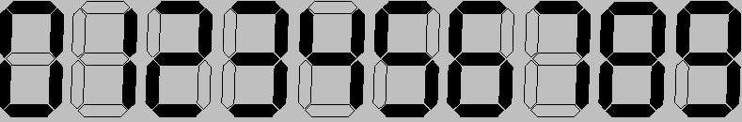

Question #7.
SW0 | SW1 | SW2 | SW3 | SW4 | SW5 | SW6 | 1-99
--------------------------------------
0 | 0 | 0 | 0 | 0 | 0 | 0 | ____
0 | 0 | 0 | 0 | 0 | 0 | 1 | ____
0 | 0 | 0 | 0 | 0 | 1 | 0 | ____
0 | 0 | 0 | 0 | 0 | 1 | 1 | ____
0 | 0 | 0 | 0 | 1 | 0 | 0 | ____
0 | 0 | 0 | 0 | 1 | 0 | 1 | ____
0 | 0 | 0 | 0 | 1 | 1 | 0 | ____
0 | 0 | 0 | 0 | 1 | 1 | 1 | ____
0 | 0 | 0 | 1 | 0 | 0 | 0 | ____
0 | 0 | 0 | 1 | 0 | 0 | 1 | ____
0 | 0 | 0 | 1 | 0 | 1 | 0 | ____
0 | 0 | 0 | 1 | 0 | 1 | 1 | ____
0 | 0 | 0 | 1 | 1 | 0 | 0 | ____
0 | 0 | 0 | 1 | 1 | 0 | 1 | ____
0 | 0 | 0 | 1 | 1 | 1 | 0 | ____
0 | 0 | 0 | 1 | 1 | 1 | 1 | ____
0 | 0 | 1 | 0 | 0 | 0 | 0 | ____
0 | 0 | 1 | 0 | 0 | 0 | 1 | ____
0 | 0 | 1 | 0 | 0 | 1 | 0 | ____
0 | 0 | 1 | 0 | 0 | 1 | 1 | ____
0 | 0 | 1 | 0 | 1 | 0 | 0 | ____
0 | 0 | 1 | 0 | 1 | 0 | 1 | ____
0 | 0 | 1 | 0 | 1 | 1 | 0 | ____
0 | 0 | 1 | 0 | 1 | 1 | 1 | ____
0 | 0 | 1 | 1 | 0 | 0 | 0 | ____
0 | 0 | 1 | 1 | 0 | 0 | 1 | ____
0 | 0 | 1 | 1 | 0 | 1 | 0 | ____
0 | 0 | 1 | 1 | 0 | 1 | 1 | ____
0 | 0 | 1 | 1 | 1 | 0 | 0 | ____
0 | 0 | 1 | 1 | 1 | 0 | 1 | ____
0 | 0 | 1 | 1 | 1 | 1 | 0 | ____
0 | 0 | 1 | 1 | 1 | 1 | 1 | ____
0 | 1 | 0 | 0 | 0 | 0 | 0 | ____
0 | 1 | 0 | 0 | 0 | 0 | 1 | ____
0 | 1 | 0 | 0 | 0 | 1 | 0 | ____
0 | 1 | 0 | 0 | 0 | 1 | 1 | ____
0 | 1 | 0 | 0 | 1 | 0 | 0 | ____
0 | 1 | 0 | 0 | 1 | 0 | 1 | ____
0 | 1 | 0 | 0 | 1 | 1 | 0 | ____
0 | 1 | 0 | 0 | 1 | 1 | 1 | ____
0 | 1 | 0 | 1 | 0 | 0 | 0 | ____
0 | 1 | 0 | 1 | 0 | 0 | 1 | ____
0 | 1 | 0 | 1 | 0 | 1 | 0 | ____
0 | 1 | 0 | 1 | 0 | 1 | 1 | ____
0 | 1 | 0 | 1 | 1 | 0 | 0 | ____
0 | 1 | 0 | 1 | 1 | 0 | 1 | ____
0 | 1 | 0 | 1 | 1 | 1 | 0 | ____
0 | 1 | 0 | 1 | 1 | 1 | 1 | ____
0 | 1 | 1 | 0 | 0 | 0 | 0 | ____
0 | 1 | 1 | 0 | 0 | 0 | 1 | ____
0 | 1 | 1 | 0 | 0 | 1 | 0 | ____
0 | 1 | 1 | 0 | 0 | 1 | 1 | ____
0 | 1 | 1 | 0 | 1 | 0 | 0 | ____
0 | 1 | 1 | 0 | 1 | 0 | 1 | ____
0 | 1 | 1 | 0 | 1 | 1 | 0 | ____
0 | 1 | 1 | 0 | 1 | 1 | 1 | ____
0 | 1 | 1 | 1 | 0 | 0 | 0 | ____
0 | 1 | 1 | 1 | 0 | 0 | 1 | ____
0 | 1 | 1 | 1 | 0 | 1 | 0 | ____
0 | 1 | 1 | 1 | 0 | 1 | 1 | ____
0 | 1 | 1 | 1 | 1 | 0 | 0 | ____
0 | 1 | 1 | 1 | 1 | 0 | 1 | ____
0 | 1 | 1 | 1 | 1 | 1 | 0 | ____
0 | 1 | 1 | 1 | 1 | 1 | 1 | ____
1 | 0 | 0 | 0 | 0 | 0 | 0 | ____
1 | 0 | 0 | 0 | 0 | 0 | 1 | ____
1 | 0 | 0 | 0 | 0 | 1 | 0 | ____
1 | 0 | 0 | 0 | 0 | 1 | 1 | ____
1 | 0 | 0 | 0 | 1 | 0 | 0 | ____
1 | 0 | 0 | 0 | 1 | 0 | 1 | ____
1 | 0 | 0 | 0 | 1 | 1 | 0 | ____
1 | 0 | 0 | 0 | 1 | 1 | 1 | ____
1 | 0 | 0 | 1 | 0 | 0 | 0 | ____
1 | 0 | 0 | 1 | 0 | 0 | 1 | ____
1 | 0 | 0 | 1 | 0 | 1 | 0 | ____
1 | 0 | 0 | 1 | 0 | 1 | 1 | ____
1 | 0 | 0 | 1 | 1 | 0 | 0 | ____
1 | 0 | 0 | 1 | 1 | 0 | 1 | ____
1 | 0 | 0 | 1 | 1 | 1 | 0 | ____
1 | 0 | 0 | 1 | 1 | 1 | 1 | ____
1 | 0 | 1 | 0 | 0 | 0 | 0 | ____
1 | 0 | 1 | 0 | 0 | 0 | 1 | ____
1 | 0 | 1 | 0 | 0 | 1 | 0 | ____
1 | 0 | 1 | 0 | 0 | 1 | 1 | ____
1 | 0 | 1 | 0 | 1 | 0 | 0 | ____
1 | 0 | 1 | 0 | 1 | 0 | 1 | ____
1 | 0 | 1 | 0 | 1 | 1 | 0 | ____
1 | 0 | 1 | 0 | 1 | 1 | 1 | ____
1 | 0 | 1 | 1 | 0 | 0 | 0 | ____
1 | 0 | 1 | 1 | 0 | 0 | 1 | ____
1 | 0 | 1 | 1 | 0 | 1 | 0 | ____
1 | 0 | 1 | 1 | 0 | 1 | 1 | ____
1 | 0 | 1 | 1 | 1 | 0 | 0 | ____
1 | 0 | 1 | 1 | 1 | 0 | 1 | ____
1 | 0 | 1 | 1 | 1 | 1 | 0 | ____
1 | 0 | 1 | 1 | 1 | 1 | 1 | ____
1 | 1 | 0 | 0 | 0 | 0 | 0 | ____
1 | 1 | 0 | 0 | 0 | 0 | 1 | ____
1 | 1 | 0 | 0 | 0 | 1 | 0 | ____
1 | 1 | 0 | 0 | 0 | 1 | 1 | ____
1 | 1 | 0 | 0 | 1 | 0 | 0 | ____
1 | 1 | 0 | 0 | 1 | 0 | 1 | ____
1 | 1 | 0 | 0 | 1 | 1 | 0 | ____
1 | 1 | 0 | 0 | 1 | 1 | 1 | ____
1 | 1 | 0 | 1 | 0 | 0 | 0 | ____
1 | 1 | 0 | 1 | 0 | 0 | 1 | ____
1 | 1 | 0 | 1 | 0 | 1 | 0 | ____
1 | 1 | 0 | 1 | 0 | 1 | 1 | ____
1 | 1 | 0 | 1 | 1 | 0 | 0 | ____
1 | 1 | 0 | 1 | 1 | 0 | 1 | ____
1 | 1 | 0 | 1 | 1 | 1 | 0 | ____
1 | 1 | 0 | 1 | 1 | 1 | 1 | ____
1 | 1 | 1 | 0 | 0 | 0 | 0 | ____
1 | 1 | 1 | 0 | 0 | 0 | 1 | ____
1 | 1 | 1 | 0 | 0 | 1 | 0 | ____
1 | 1 | 1 | 0 | 0 | 1 | 1 | ____
1 | 1 | 1 | 0 | 1 | 0 | 0 | ____
1 | 1 | 1 | 0 | 1 | 0 | 1 | ____
1 | 1 | 1 | 0 | 1 | 1 | 0 | ____
1 | 1 | 1 | 0 | 1 | 1 | 1 | ____
1 | 1 | 1 | 1 | 0 | 0 | 0 | ____
1 | 1 | 1 | 1 | 0 | 0 | 1 | ____
1 | 1 | 1 | 1 | 0 | 1 | 0 | ____
1 | 1 | 1 | 1 | 0 | 1 | 1 | ____
1 | 1 | 1 | 1 | 1 | 0 | 0 | ____
1 | 1 | 1 | 1 | 1 | 0 | 1 | ____
1 | 1 | 1 | 1 | 1 | 1 | 0 | ____
1 | 1 | 1 | 1 | 1 | 1 | 1 | ____

8. Conclusion

“This assignment is intended to:
1. Exercise students’ understanding of base conversion.
2. Exercise students’ understanding of complex logic circuits including many gates.
3. Exercise students’ ability to minimize AND-OR circuits using K-maps.
4. Exercise students’ understanding of how to do modular design using existing components.
5. Give students practice at wiring up, simulating, and debugging such circuits using the Quartus tool.
6. Continue exercising students’ ability to go through a structured design process with all appropriate documentation”. -- quoted from Lab Assignment #3 document.

